# Project Name: Pokémon Types Database

## Project Team Members

* Michal Salabura
* Bernard Joyce
* Nikita Smiichyk
* Oliver Halpenny
* Hanna Bokariuk

## Project Description

This database is designed for people playing the Pokémon game to find what is the best type of Pokémon to use in a fight and where and when to find that Pokémon type. Each species has an advantage over another which can be used to gain an advantage in a Pokémon battle. For example a water type Pokémon is more effective against a fire type Pokémon than a earth type Pokémon.

The end user being someone playing the Pokémon game might want to fight a gym leader and they might want to know what that gym leaders type specialisation is and what type has an advantage over that type and where to find that type and when to find it. For example a player could be fighting a gym leader that specialises in fire type Pokémon and they want to find what Pokémon has an advantage over fire types, then they could want to find that type so what region they are typically in and when in the game they start to show up.

#### Explaining use case with another example:

Jimmy is a 15 year old Pokemon game player and is using the database to help him play. As Jimmy I want to be to find out what Pokémon have an advantage over other Pokémon so that I can beat gym leaders easier. I also want to be able to find where these Pokémon are in the game and at what level these Pokemon will be able to be caught at in the game so that I can use them against the gym leaders.

## Primary Business Rules

**Trainers and Pokémon**

A Trainer can train many Pokémon, but each Pokémon caught belongs to exactly one Trainer.

**Trainers and Towns**

Each Trainer comes from one Town (itownID), but a Town can have many Trainers.

**Gyms and Leaders**

Each Gym must have exactly one Leader (Trainer), and each Trainer can lead one Gym.

**Towns and Gyms**

Each Gym is located in one Town, and each Town has exactly one Gym.

**Towns and Regions**

Each Town belongs to one Region, and a Region may contain zero or many Towns.

**Pokémon Species**

The TrainerPokemon table references Pokémon, meaning each caught Pokémon is of one Pokémon species, but each Pokémon species can appear in many TrainerPokemon records.

**Pokémon Types**

Each Pokémon species can have zero or more Types (e.g., Fire, Water).

Each Type can belong to many Pokémon species.

**Type Advantages**

Each Type can have advantages or disadvantages against other Types.

**Wild Pokémon**

Each Wild Pokémon species appears in one Region, but a Region can have zero or many Wild Pokémon species.

## Entity and Attribute Identification

**Trainers**

* TrainerID INT PRIMARY KEY
* HomeTownID INT FOREIGN KEY REFERENCES Towns(TownID) NOT NULL
* Name VARCHAR(50) NOT NULL
* Gender VARCHAR(50) NOT NULL
* Age INT

**TrainerPokemon**

* CaughtID INT PRIMARY KEY
* TrainerID INT FOREIGN KEY REFERENCES Trainers(TrainerID) NOT NULL
* PokemonID INT FOREIGN KEY REFERENCES Pokemon(PokemonID) NOT NULL
* Nickname VARCHAR(50) NOT NULL
* Level INT NOT NULL
* HP INT NOT NULL
* Attack INT NOT NULL
* Defense INT NOT NULL

**Gym**

* GymID INT PRIMARY KEY
* LeaderID INT FOREIGN KEY REFERENCES Trainers(TrainerID) NOT NULL
* TownID INT FOREIGN KEY REFERENCES Towns(TownID) NOT NULL
* TypeSpecialisation INT FOREIGN KEY REFERENCES Types(TypeID) NOT NULL
* BadgeID INT FOREIGN KEY REFERENCES Badges(BadgeID) NOT NULL

**Towns**

* TownID INT PRIMARY KEY
* RegionID INT FOREIGN KEY REFERENCES Regions(RegionID) NOT NULL
* Name VARCHAR(50) NOT NULL
* Population INT NOT NULL

**Regions**

* RegionID INT PRIMARY KEY
* Name VARCHAR(50) NOT NULL
* Climate VARCHAR(50) NOT NULL

**Pokemon**

* PokemonID INT PRIMARY KEY
* Name VARCHAR(50) NOT NULL
* BaseHP INT NOT NULL
* BaseAttack INT NOT NULL
* BaseDefense INT NOT NULL

**PokemonTypes**

* PokemonID INT FOREIGN KEY REFERENCES Pokemon(PokemonID) NOT NULL
* TypeID INT FOREIGN KEY REFERENCES Types(TypeID) NOT NULL

**Types**

* TypeID INT PRIMARY KEY
* TypeName VARCHAR(50) NOT NULL

**TypeAdvantages**

* Type1 INT FOREIGN KEY REFERENCES Types(TypeID) NOT NULL
* Type2 INT FOREIGN KEY REFERENCES Types(TypeID) NOT NULL
* AdvantageType VARCHAR(50) NOT NULL

**WildPokemon**

* WildID INT PRIMARY KEY
* PokemonID INT FOREIGN KEY REFERENCES Pokemon(PokemonID) NOT NULL
* RegionID INT FOREIGN KEY REFERENCES Regions(RegionID) NOT NULL
* LocationDescription VARCHAR(50) NOT NULL
* MinLevel INT NOT NULL
* MaxLevel INT NOT NULL

**Badge**

* BadgeID INT PRIMARY KEY
* Name VARCHAR(50) NOT NULL

## Sample Test Data in Combined Tables

Pokemon + Type Table

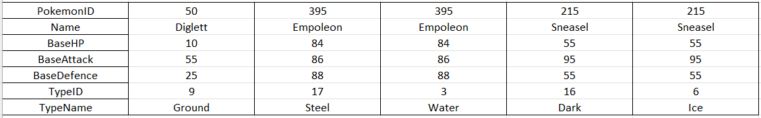

Trainer + Trained Pokemon

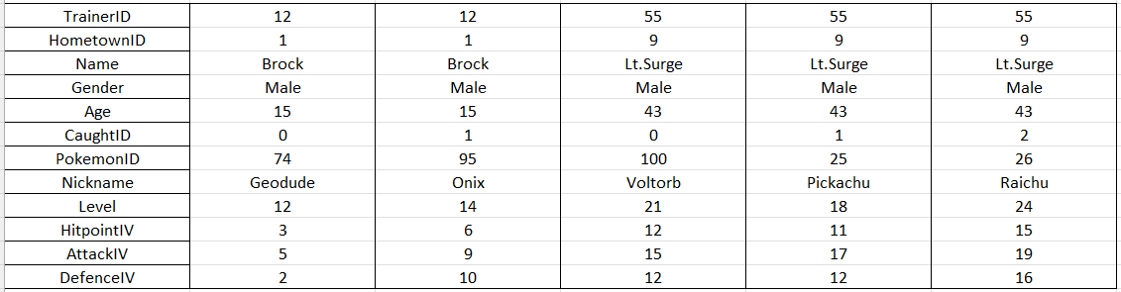

Regions + Towns

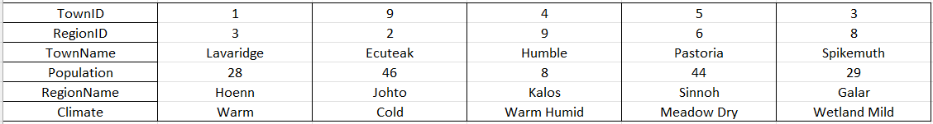

## ER Diagram Representation

